Battleship Game - Design & Feedback
1. Design Phase
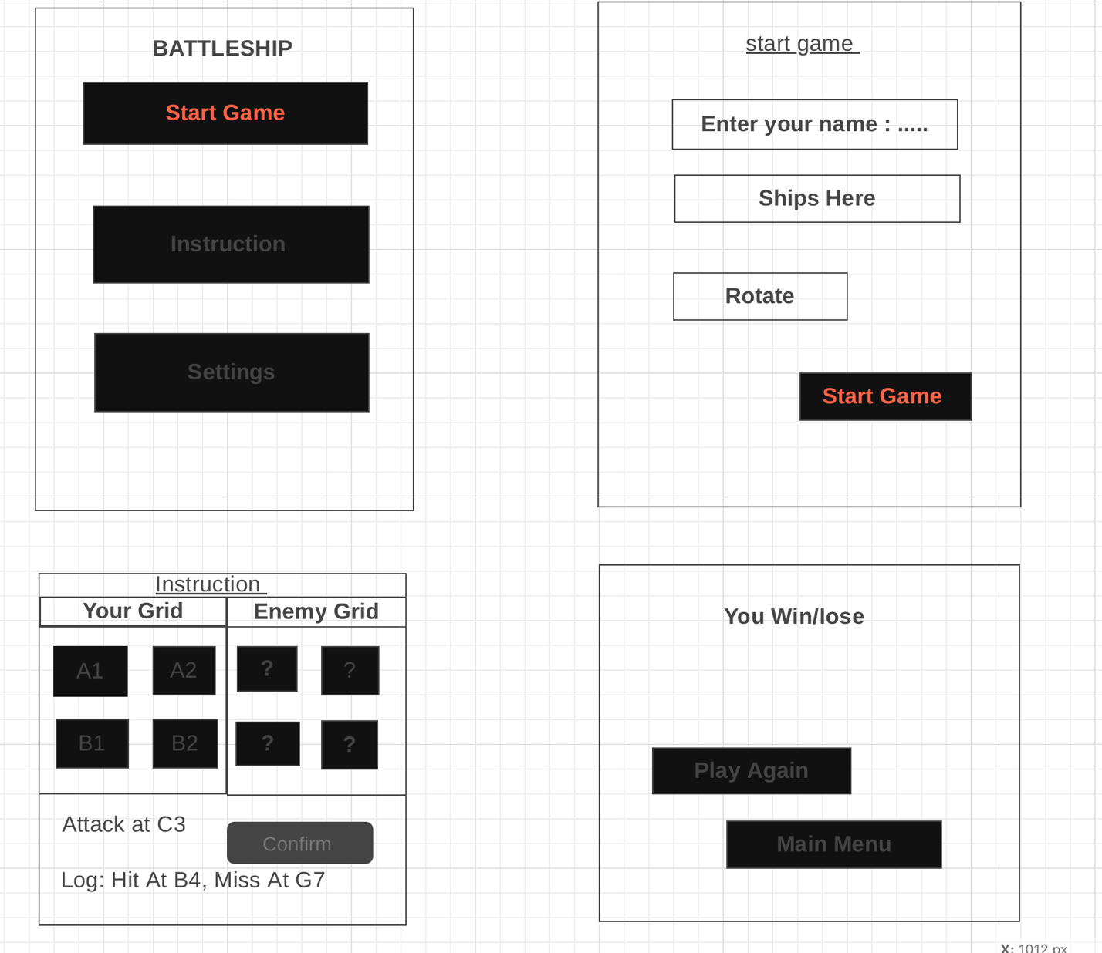
I made the first design for my Battleship game using paper and pencil. My design includes:
- Main Menu – Start Game, Instructions, Settings
- Game Setup – Enter player name, place ships on the grid
- Game Screen – Player’s grid, enemy grid, attack button, move log
- Result Screen – Show win or lose, replay button, return to menu
Each part is clear and easy to understand.
2. Review & Feedback
I showed my design to my sister, who studies Computer Science.
What She Said:
- Clear? – The design is good, but the instructions need more details.
- Complete? – She said I should add a rotate button to move ships.
- Easy to Use? – She said the attack button should be bigger.
- Future Growth? – We talked about adding AI difficulty levels later.
What I Changed:
- Added a rotate button for ships.
- Wrote better instructions for the game.
- Made the attack button bigger.

